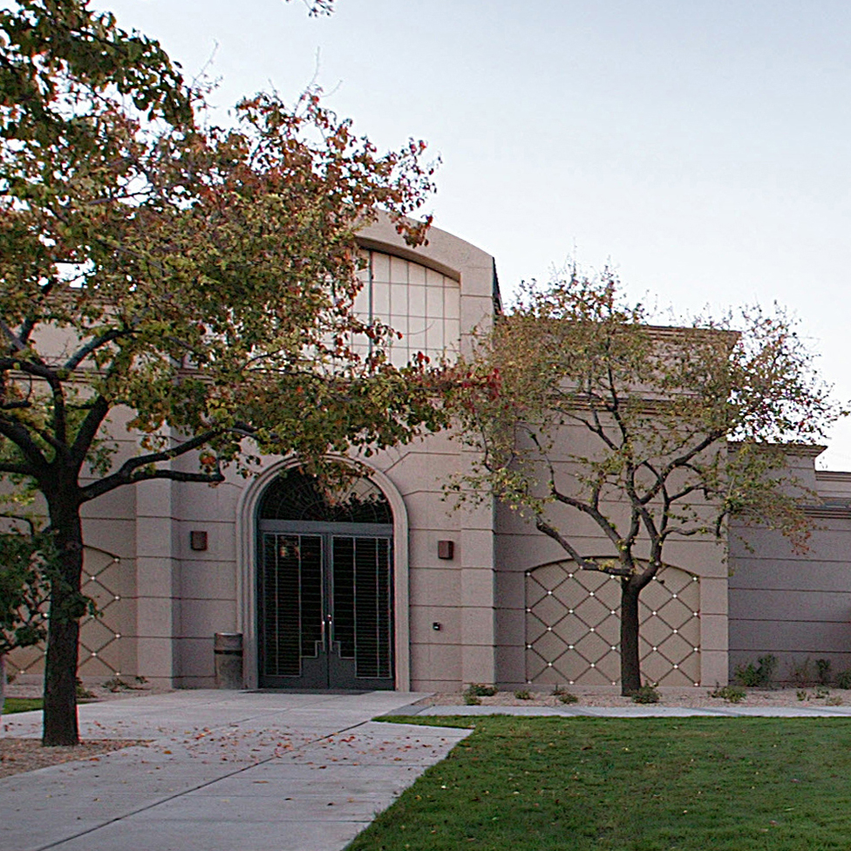

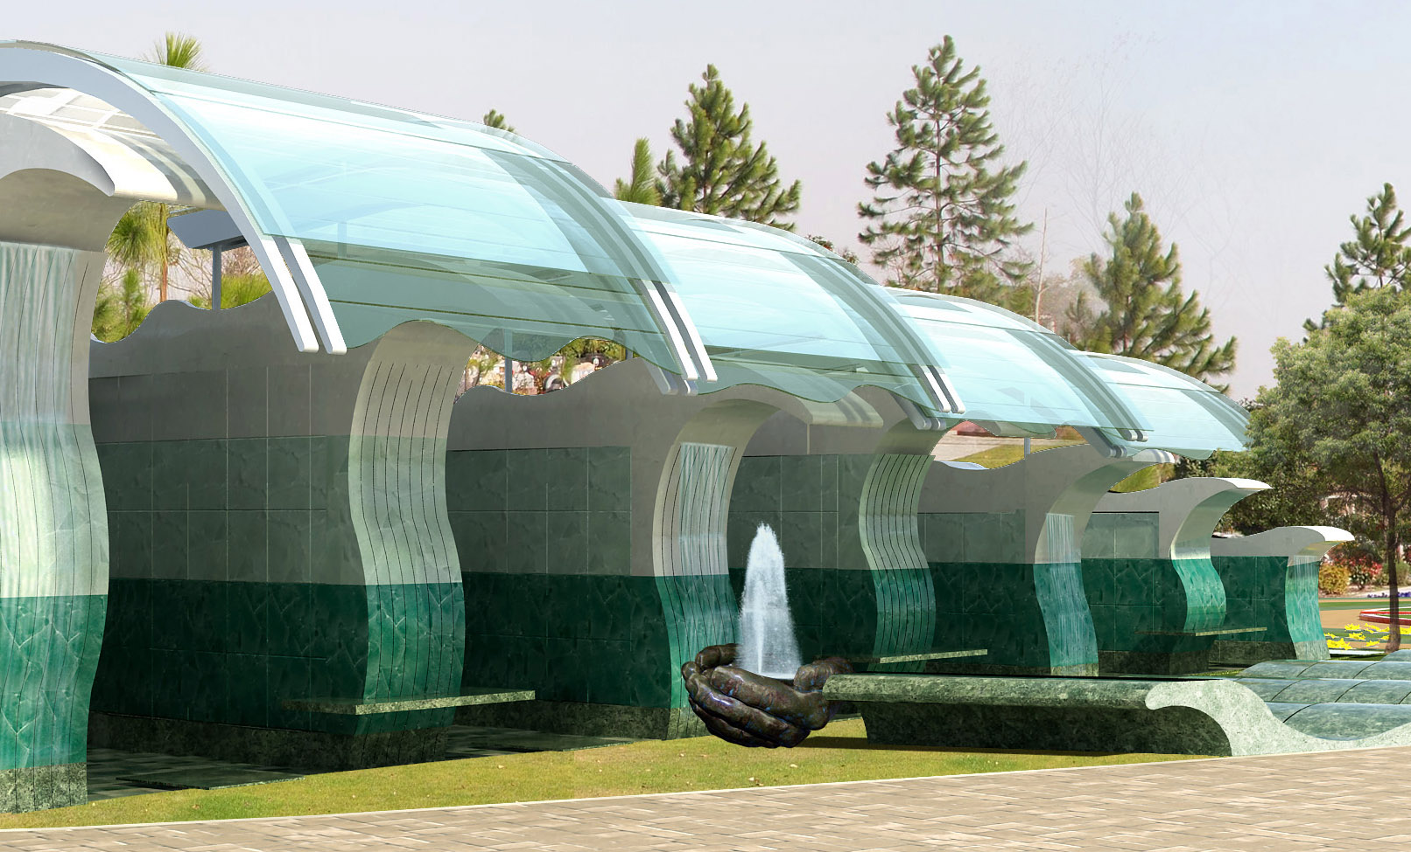
PROFILE Senior Designer – Design Manager: designed and consulted on residential, retirement, mixed-use, commercial, mausolea, chapels, and columbaria projects, across the US, Canada, Australia, and development. Design Projects, Consult on projects, Team management, Client contact, Travel (across US, Canada, Australia, China, and Europe), consultant management (develop, implement, manage contracts), construction design management (document review, outline specs, RFI’s, ASI’s, submittal review), attendance at sales conventions.
EDUCATION Bachelor of Architecture University of Oregon 1984
Study Abroad Waseda University, Tokyo 1978-79
License Architect State of Oregon 1992
SKILLS AutoCAD, Photoshop, Excel, Word, etc.
EXPERIENCE Milne Construction Co. US / Canada / Australia
Design Manager & Architect 2003-Present
Cemetery Structures, Chapels, Mausolea, Columbaria, Master Plans.
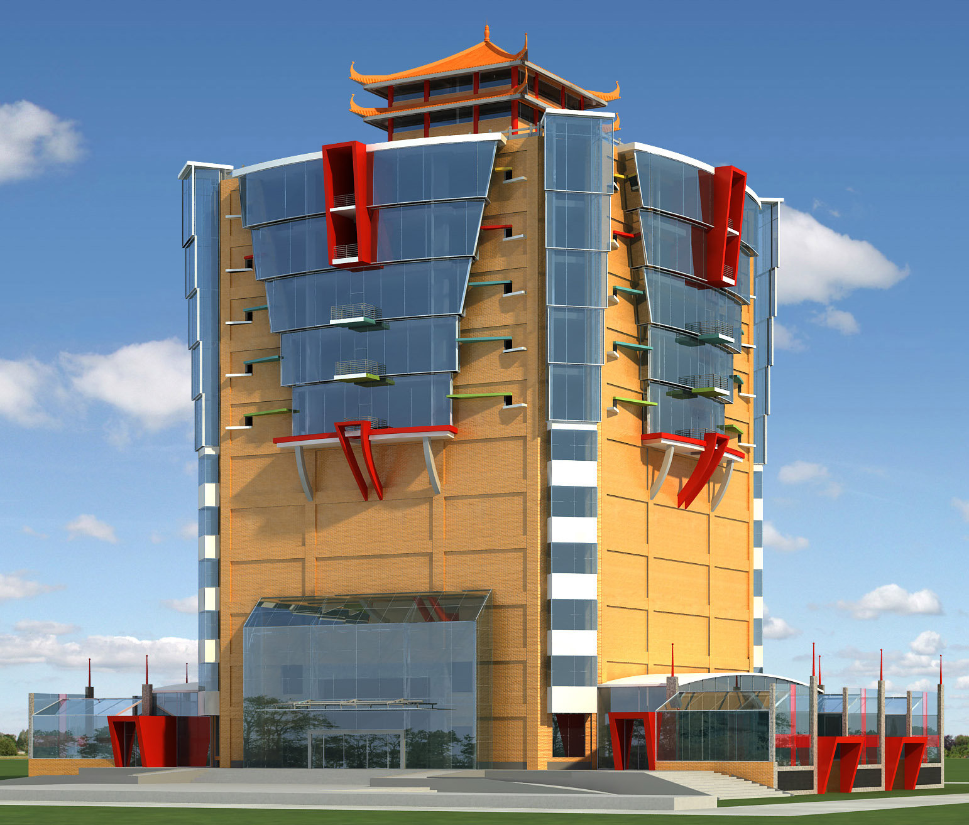
Benner Stange Assoc. Architects – Lake Oswego, OR Senior Designer / Project Architect 2000-2003
Commercial Retail / Mixed-Use
Clinton Pearson Architect – Portland, OR
Principal / Owner 1992-2003
Commercial / Residential
Stewart Straus, Architect – Portland, OR
Designer / draftsman / intern 1988-1992
Commercial / Retail
Curry Brandaw Architects – Salem, OR
Designer / draftsman / intern 1986-1988
Housing / Retirement Facilities
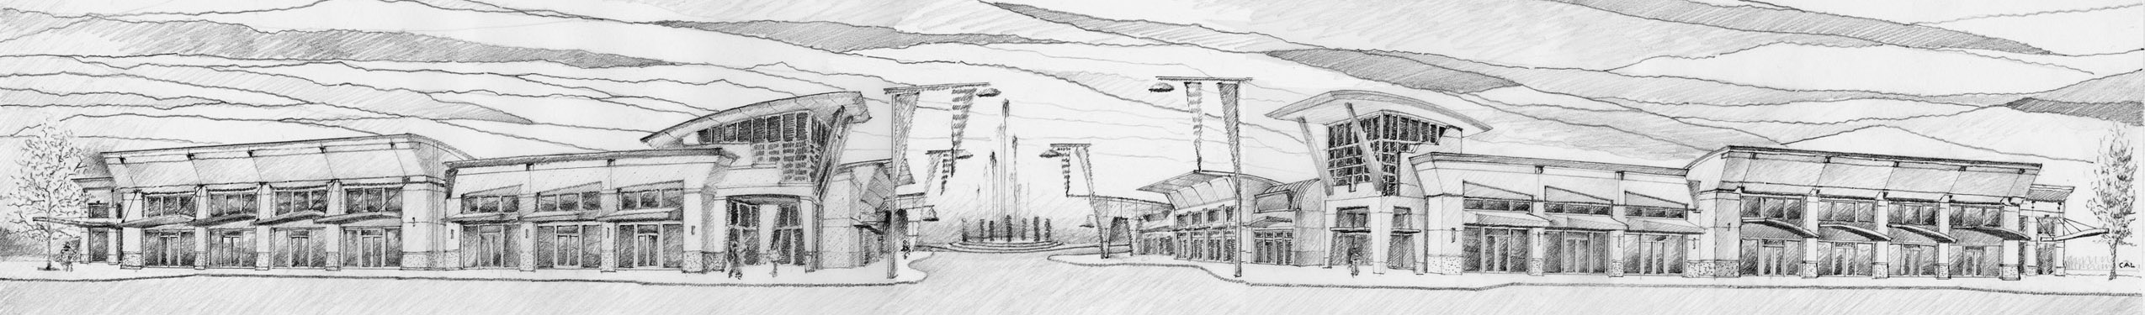
Don Nelson, Architect – Portland, OR
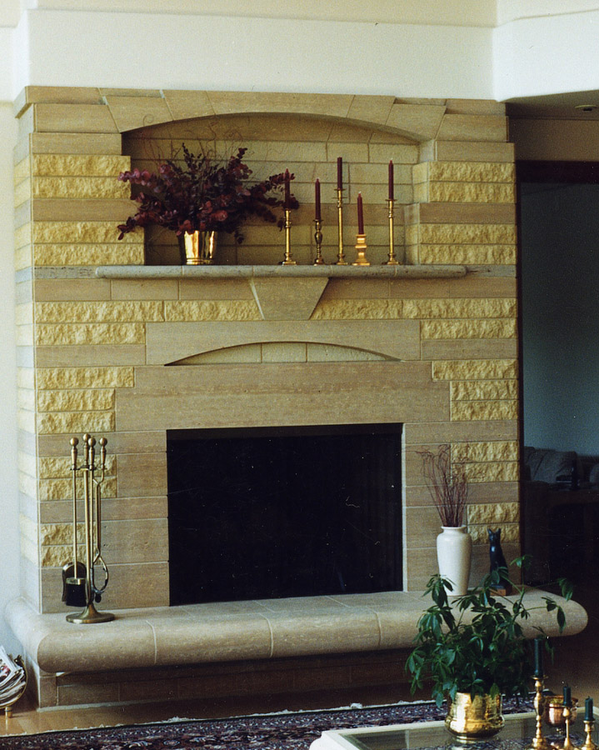
Designer / draftsman / intern 1985
Hospitality / Housing / Retail
William Neel, Architect – Eugene, OR
Designer / draftsman / intern 1985
Commercial / Residential
Slater-Paul & Assoc. – Denver, CO
Designer / draftsman / intern 1985
Retail / Telecommunications
Campus Planning Office, Univ Of Oregon – Eugene, OR
Draftsman 1976-1978 & 1979-1981
Campus remodels
Significant
Projects

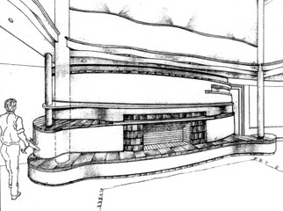
Commerical Mixed-use Retail / Condos, Bethany Village, Portland, OR; Safeway & Pad Buildings, Woodburn, OR; Cascade Station Master Plan, Portland, OR; Mausoleum Myrtle Hill Cemetery, Rome, GA; Men’s Wearhouse, Tanasbourne, Hillsboro, OR; Pacific Fir Lumber Office & Warehouse, Sheridan, OR; Tecna Industries Truss Manufacturing Facility, McMinnville, OR; Emerson Hardwood Wholesale Facility and Office, Portland, OR; Video Store, Aloha, OR.; Lakewood Mall, Tacoma, WA; Target, Hazel Dell, Vancouver, WA.

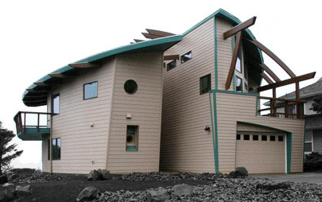
Cemetery Master Plan & Mausoleum, Moravian Cemetery, Staten Island, NY; Mausoleum, Queen’s Park Cemetery, Calgary, Canada; Mausoleum Paradise Memorial Gardens, Scottsdale, AZ; Sunset Mausoleum, Bellevue Cemetery, Ontario, CA; Cathedral Mausoleum Addition & Beth Olam Mausoleum Addition, Hollywood Forever Cemetery, Los Angeles, CA.

Residential Lincoln City, OR Beach House; Neskowin, OR Beach House; Residence, Oak Grove, OR; Bonica Beach House, Lincoln City, OR; Rudin residence, Lake Oswego, OR; Aarnio Residence, Oak Grove, OR.
CompetitionSopporo Dome Soccer Stadium, Finalist 1997

